Table of Contents

1. Introduction: What is CSS?
CSS (Cascading Style Sheets) is a stylesheet language describing the presentation of HTML documents. It controls appearance, layout, colors, fonts, animations, and responsive design—transforming raw HTML structure into visually coherent, usable interfaces (World Wide Web Consortium, 2024). While HTML provides semantic skeleton and JavaScript adds behavioral logic, CSS governs the aesthetic layer that determines how users perceive and interact with web content.
The portfolio's `styles.css` demonstrates sophisticated CSS architecture, employing CSS variables for maintainable theming, modern layout systems for responsive design, and animation keyframes for dynamic user experiences. This section examines these techniques as implemented in the live portfolio.

2. Custom CSS Variables and Design Systems
The portfolio defines global CSS variables within the `:root` selector, establishing a cohesive design system:
:root {
--bg-primary: #1b1b1b;
--bg-secondary: #e5dcd1;
--bg-accent: #ff471d;
--text-primary: #e5dcd1;
--font-primary: 'VT323', monospace;
--font-body: 'Space Mono', monospace;
--font-display: 'Oswald', sans-serif;
}
This variable-driven approach ensures consistency across the entire portfolio. Changing the accent color from `#ff471d` to another value updates every instance—from buttons to borders to hover states—throughout the codebase from a single location. The design system encompasses a dark primary background (`#1b1b1b`), warm secondary tones (`#e5dcd1`), vibrant orange accents (`#ff471d`), and a typographic hierarchy combining monospace body text with display headings (World Wide Web Consortium, 2024).
The portfolio also implements a scanline overlay effect using CSS gradients, creating subtle visual texture through `repeating-linear-gradient` patterns. This aesthetic choice reflects intentional design decisions where CSS transcends mere styling to establish mood and identity.

3. The CSS Property Playground
The portfolio incorporates an interactive CSS Property Playground (Figure 1) where users manipulate sliders to observe real-time property transformations. Controls include border-radius (0-50px), transform: rotate() (0-360 degrees), filter: blur() (0-10px), opacity (0-1), and scale (0.5-2.0), with a color picker offering six preset backgrounds.
As users adjust values, inline styles dynamically apply to a preview box while a generated CSS code block updates simultaneously. This demonstrates how CSS properties compound—`transform: rotate(45deg) scale(1.2)` combines rotation and scaling in a single declaration—and how the cascade prioritizes inline styles over external stylesheets. The playground effectively bridges theoretical property knowledge with practical visual feedback, making abstract CSS concepts tangible and memorable (Mozilla Foundation, 2024).
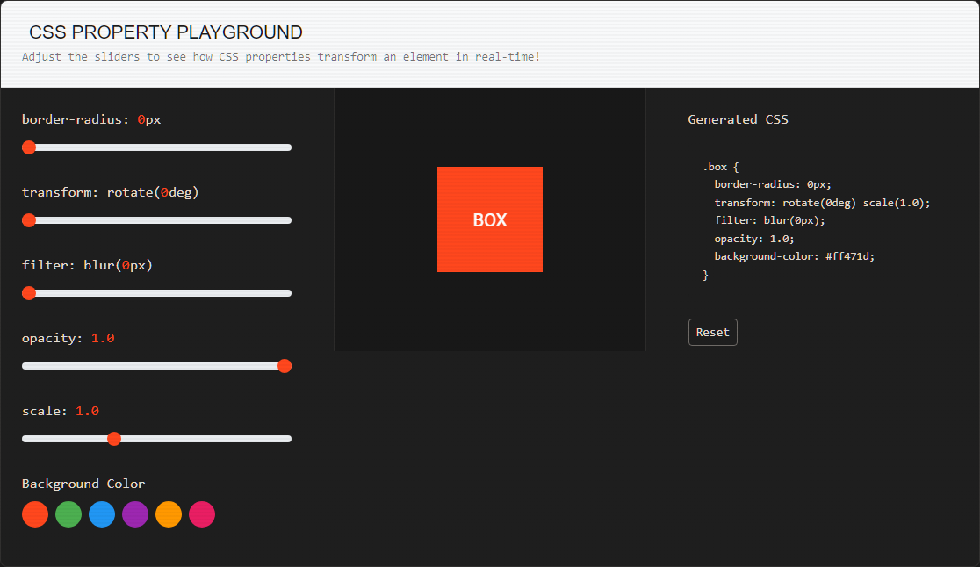
Figure 1: CSS Property Playground with Sliders and Preview

4. Layout Mastery: Flexbox and Grid

4.1 Flexbox Layout
Flexbox provides one-dimensional layout control for arranging items in rows or columns. The portfolio's implementation demonstrates `display: flex` with interactive controls for `flex-direction` (row/column) and `justify-content` (flex-start, center, space-between). Flexbox excels at distributing space along a single axis, making it ideal for navigation bars, card alignments, and centering operations that previously required complex hacks.
The visual demo (Figure 2) shows four numbered items responding immediately to control changes, with accompanying code blocks updating to reflect current CSS rules. This interactivity reveals Flexbox's behavior more effectively than static examples—users observe how `justify-content: space-between` distributes items across the container's full width, while `center` clusters them in the middle.
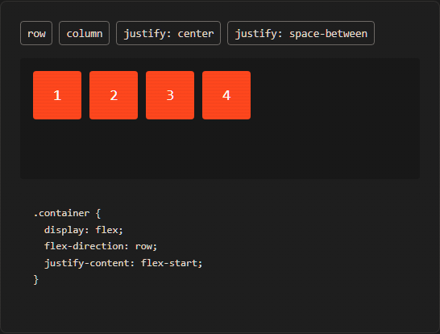
Figure 2: Flexbox Layout Control Demonstration

4.2 CSS Grid Layout
CSS Grid offers two-dimensional control over rows and columns simultaneously. The portfolio's Grid demo (Figure 3) features six items arranged via `grid-template-columns: repeat(3, 1fr)` with interactive toggles for 2, 3, or 4 columns and gap adjustment. Grid proves superior for complex page layouts requiring precise alignment across both axes, such as the portfolio's overall section structure and component arrangements.
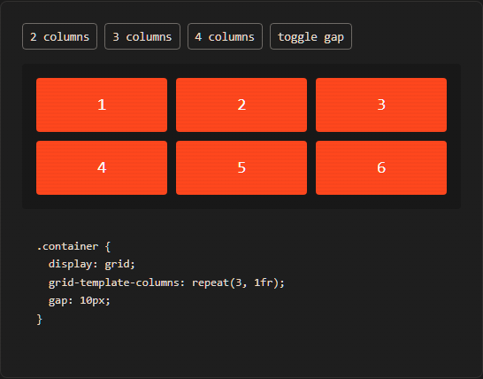
Figure 3: CSS Grid Layout with Dynamic Columns
The comparison between Flexbox and Grid is not competitive but complementary—Flexbox handles component-level alignment within Grid containers, while Grid manages macro-level page architecture. Understanding when to deploy each system marks the transition from CSS competence to mastery (Mozilla Foundation, 2024).

5. CSS Animations and Keyframes
The portfolio showcases five CSS animations using `@keyframes`: bounce (vertical translation), pulse (scaling), spin (rotation), shake (horizontal displacement), and glow (box-shadow intensity). Each animation is defined by specifying property values at percentage points along the animation timeline, with the browser interpolating between states.
For example, the bounce animation defines `transform: translateY(0)` at 0% and 100%, with `translateY(-30px)` at 50%, creating a smooth oscillation. The glow animation manipulates `box-shadow` spread radius, producing a pulsating light effect around elements. These animations execute entirely without JavaScript, demonstrating CSS's capability for performant, GPU-accelerated motion graphics (World Wide Web Consortium, 2024).
The portfolio applies these principles throughout: floating code elements in the hero section use gentle vertical translation; the scroll indicator pulses to draw attention; and interactive elements transition smoothly on hover. Such animations enhance user experience when used judiciously, providing visual feedback and guiding attention without overwhelming content.

6. Reflection
Working extensively with CSS revealed the immense power of modern layout systems. Previously, centering elements or creating responsive grids required frustrating workarounds; mastering Flexbox and Grid made these operations intuitive. CSS variables emerged as a game-changer for maintaining consistent design systems—updating a single `--bg-accent` value propagates changes across hundreds of rules. The portfolio's aesthetic coherence derives directly from this systematic approach, where every color, spacing value, and typographic choice connects to central variables. CSS is not merely decoration but a structural discipline that shapes how users perceive and navigate digital spaces.

7. References
Bootstrap Team (2024) Bootstrap: The most popular HTML, CSS, and JS library. Available at: https://getbootstrap.com/ (Accessed: 17 June 2026).
Mozilla Foundation (2024) MDN Web Docs. Available at: https://developer.mozilla.org/ (Accessed: 17 June 2026).
World Wide Web Consortium (2024) W3C. Available at: https://www.w3.org/ (Accessed: 17 June 2026).

